Project Phase - I Solution Architecture

|  |  |
| --- | --- |
| Date | 16.10.2022 |
| Team ID | PNT2022TMID26790 |
| Project Name | Real -Time Communication System Powered by AI for Specially abled |

# Solution Architecture:

Solution architecture is a complex process – with many sub-processes – that bridges the gap between business problems and technology solutions. Its goals are to:

 Find the best tech solution to solve existing business problems.

 Describe the structure, characteristics, behavior, and other aspects of the software to project stakeholders.

 Define features, development phases, and solution requirements.

 Provide specifications according to which the solution is defined, managed, and delivered. Solution Architecture Diagram:

# Solution Architecture Design:

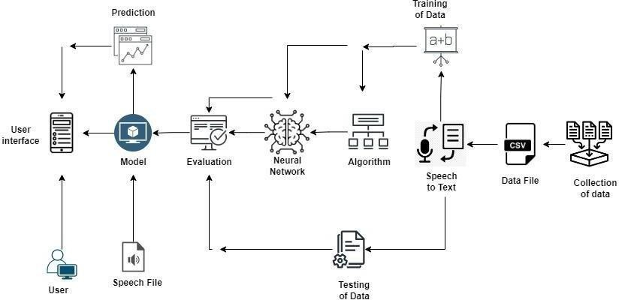

*Figure*: Architecture design and data flow of the real time communication powered by AI specially abled.